**ASSIGNMENT 17.1**

PROBLEM STATEMENT:

1) Write a program to read a text file and print the number of rows of data in the document.

Solution:

The text file is named as ‘story’ where an article is written which consist of 3 rows.



Output:



2) Write a program to read a text file and print the number of words in the document.

Solution and Output:

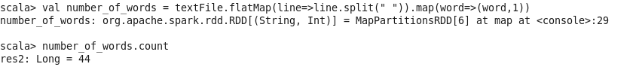

3) We have a document where the word separator is -, instead of space. Write a spark code, to obtain the count of the total number of words present in the document.

Sample document:

This-is-my-first-assignment.

It-will-count-the-number-of-lines-in-this-document.

The-total-number-of-lines-is-3

Solution:

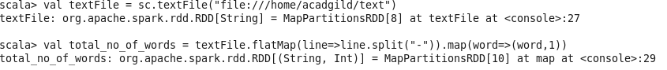

Output:

